**SPRINT 2**

|  |  |
| --- | --- |
| Date | 03 November 2022 |
| Team ID | PNT2022TMID40580 |
| Project Name | DETECTING PARKINSON’S DISEASE USING  MACHINE LEARNING |
| Maximum Marks | 4 Marks |

3.Get the features and labels from the DataFrame (dataset). The features are all the columns except ‘status’, and the labels are those in the ‘status’ column.

* 1. #DataFlair - Get the features and labels
  2. features=df.loc[:,df.columns!='status'].values[:,1:]
  3. labels=df.loc[:,'status'].values

**Screenshot:**

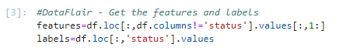

4.The ‘status’ column has values 0 and 1 as labels; let’s get the counts of these labels for both- 0 and 1.

1. #DataFlair - Get the count of each label (0 and 1) in labels
2. print(labels[labels==1].shape[0], labels[labels==0].shape[0])

**Output Screenshot:**

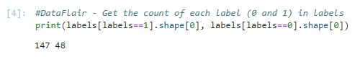

We have 147 ones and 48 zeros in the status column in our dataset.